
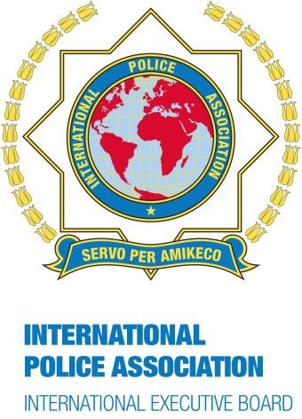
1

INTERNATIONAL POLICE ASSOCI
ATION
–

INTERNTIONAL EXECUTIVE BOARD

NGO in Consultative (Special) Status with the Economic and Social

Council of the United Nations;

in Consultative S
tatus with
the Organiz
ation of American States

and UNESCO

IPA
INTERNATIO
NAL
VIDEO

COMPETITION 20
2
41

Arts and Culture Project
-

ENTRY FORM 20
2
4

Vi
deo
t
itle:

IPA
s
ection:

C
ontact per
son:

Email:

Brief description of
v
ideo

submitted:

By submitting the above-mentioned video, my section and all persons featured in the video
authorise the IPA to use the video for this competition, in IPA publications, on IPA websites
and social media.
Please submit your video together with this form by 1 September 2024

artsandcultureprojectteam@gmail.com

,

Christos Parginos

Chair Person Socio Cultural Commission
-

-
chair-SCC@ieb-ipa.org

